

#### Faculty of Science and Technology

# ITE 475 DATA COMMUNICATION AND COMPUTER NETWORKS

**Final Exam 1/2020**

## Instructor: Ajarn Ilogu Ikechukwu Time: 2:00 hours

## No. of Pages: 4 (include cover page)

**NAME: Fardina Kabir**

**STUDENT ID. NO. 1910080005 Roster No.**

**INSTRUCTIONS:**

* This exam accounts for 30% of the overall course assessment.
* You may NOT use any other Internet resource, written notes, or any form of communication with others.
* Communication devices are NOT permitted during this examination.
* Any form of dishonesty including talking, consulting, copying, exchanging flash drives, moving to another's workstation after they leave, bringing in unauthorized study materials or electronic devices of any form will lead to disqualification from the examination.
* If you are not sure about what a question is asking, state your assumptions and answer the question accordingly.
* There will be NO RESTROOM BREAK; if you must use the restroom, make sure you are finished and submit your exam to the proctor before leaving the classroom.

**POINTS DISTRIBUTION:**

|  |  |  |  |  |  |
| --- | --- | --- | --- | --- | --- |
| **Part** | | **Description** | | **No of Questions** | **Possible Score** |
| **Part A** | | **Inter-Networking** | | **5** | **10** |
| **Part B** | | **Lab Work** | | **1** | **10** |
| **Part C** | | **Routing Protocols** | | **5** | **5** |
| **Part D** | | **General Networking** | | **5** | **5** |
| **Total** | |  | | **30** |

**Part A: Inter-Networking**

1. **What is the difference between router and switch?**

Router-The main objective of router is to connect various networks simultaneously. It works in network layer. Router is used by LAN as well as MAN. Through router data is sent in the form of packet. It is a full duplex mode transmission. There is less collision take place in router. Router is compatible with NAT. The types of routing are: Adaptive and Non-adaptive routing.

Switch-While the main objective of switch is to connect various devices simultaneously.

While it works in data link layer. While switch is used by only LAN. While through switch data is sent in the form of packet and frame. It is also a full duplex mode transmission. While there is no collision take place in full duplex switch. While it is not compatible with NAT. The types of switching are: Circuit, Packet and Message Switching.

1. **List the seven OSI layers and mention at least 2 protocols that work on each layer?**

**Physical, Data Link, Network, Transport, Session, Presentation, and Application.**

|  |  |  |
| --- | --- | --- |
| **OSI Layer** | **Name** | **Common Protocols** |
| **7** | **Application** | **HTTP | FTP | SMTP | DNS | Telnet** |
| **6** | **Presentation** |  |
| **5** | **Session** |  |
| **4** | **Transport** | **TCP | SPX** |
| **3** | **Network** | **IP | IPX** |
| **2** | **Data Link** | **Ethernet** |
| **1** | **Physical** |

1. **What is the difference between Administrative Distance and Autonomous System number?**

**Administrative Distance (AD)** is used to rate the trustworthiness of routing information received from the neighbour router. The route with the least AD will be selected as the best route to reach the destination remote network and that route will be placed in the routing table. It defines how much reliable a routing protocol is. It is an integer value ranging from 0 to 255 where 0 shows that the route is most trusted and 255 means that no traffic will be passed through that route or that route is never installed in the routing table.

**Autonomous System (AS)** is a group of routers and networks working under a single administrative domain. It is a 16 bit value which defines the routing domain of the routers. These numbers range from 1 to 65535.

* **Public Autonomous System Number –**  
  These are 16 bit values which range from 1 to 64511.The service provider will provide a public AS if the customer is connected to more than one ISPs such as multihoming. A global autonomous number, which will be unique, is provided when the customer wants to propagate it’s BGP routes through 2 ISPs.
* **Private Autonomous system Number –**  
  Private Autonomous System Number are 16 bit values which range from 64512 to 65535.The service provider will provide a private autonomous system number to the customer when the customer wants multi connection to a single ISP (single home or dual home network) but not to more than one ISPs. These are provided in order to conserve the autonomous system numbers.
* **Assigning of AS numbers –**  
  The Autonomous numbers are first assigned by IANA (Internet Assign Number Authority) to the respective regional registries. Further, the regional registry distribute these autonomous numbers (from the block of autonomous numbers provided by IANA) to entities within their designated area.

1. **Describe briefly difference between a collision domain and a broadcast domain?**

**Collision Domain –**  
A Collision Domain is a scenario in which when a device sends out a message to the network, all other devices which are included in its collision domain have to pay attention to it, no matter if it was destined for them or not. This causes a problem because, in a situation where two devices send out their messages simultaneously, a collision will occur leading them to wait and re-transmit their respective messages, one at a time. Remember, it happens only in case of a half-duplex mode.

**Broadcast Domain –**  
A Broadcast Domain is a scenario in which when a device sends out a broadcast message, all the devices present in its broadcast domain have to pay attention to it. This creates a lot of congestion in the network, commonly called LAN congestion, which affects the bandwidth of the users present in that network.

**Part B: Lab Work.**

**Use the diagram below to answer the configuration questions.**

**(A) Initial Router configuration.**

i) Change router hostname.

ii) Configure line console.

iii) Configure VTY.

iv) Configure AUX.

v) Configure enable password.

vi) Configure secret password.

vii) Encrypt all your passwords.

**(B) Configure Router Interfaces.**

**(C) Assign ip addresses to VPCs.**

**(D) Configure EIGRP in all Routers.**

**(E) VPC1 MUST Ping VPC3.**

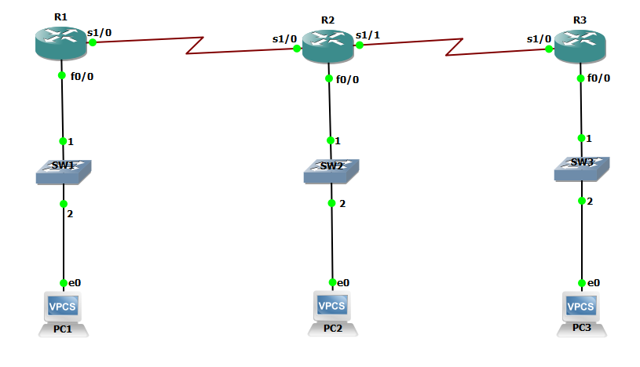

**Configuration Requirements.**

Router 1: s1/0 == 172.17.0.1 /16 Router 2: s1/0 == 172.17.0.2 /16

Switch 1: f/0 == 172.16.0.1 /16 s1/1 == 172.19.0.1 /16

VPC 1: == 172.16.0.10 /16 Switch 2: f0/0 == 172.18.0.1 /16

VPC2: == 172.18.0.10 /16

Router 3: == 172.19.0.2 /16

Switch 3: == 172.20.0.1 /16

VPC 3: == 172.20.0.10 /16

**Part C: Routing Protocols / Commands**

1. **What is the Administrative Distance of the following routing Protocols?**

a) RIP -------- 120

b) EIGRP -------- 90

c) OSPF -------- 110

d) STATIC ROUTE -- 1

e) CONNECTED INTERFACE --- 0

1. **What is the difference between Routing Protocol and Routed Protocol?**

**A *routed* protocol is a protocol by which data can be routed. Examples of a routed protocol are IP, IPX, and AppleTalk. Required in such a protocol is an addressing scheme. Based on the addressing scheme, you will be able to identify the network to which a host belongs, in addition to identifying that host on that network. All hosts on an internetwork (routers, servers, and workstations) can utilize the services of a routed protocol.**

**A *routing* protocol, on the other hand, is only used between routers. Its purpose is to help routers building and maintain routing tables. The only two routed protocols you should worry about are IP and IPX (although Cisco has dropped IPX from the latest CCNA exam, it is helpful to understand the concepts behind it).**

1. **Briefly explain any of the Routed Protocols (DNS / FTP / HTTP / DHCP / SSH)?**

**HTTP (Hypertext Transfer Protocol)**

**It is the TCP/IP based application layer protocol and is deployed to transport data in the form of image, video, text, HTML files and query results on the World Wide Web.**

**The default port assigned to it is 80, however, the other ports are also applicable. It is basically the standardization of communication between various machines on the Internet to communicate with each other.**

**Features**

* **Connectionless: Unlike FTP, in which the connection is established and continued till the end of the entire communication session, the HTTP is connectionless.**
* **The HTTP client is the one in which the browser starts up an HTTP request and after the request is raised it disconnects itself from the server and holds up for a response. When the server is ready with the response, it again makes a new connection with the client and delivers the response.**
* **Media free: Data in any form like voice, text or video can be sent over it, as it is the duty of the client and the server to handle the analyzing part at their respective ends.**
* **Stateless: The client and the server are concerned about the network addresses and other information about each other only during the communication session and after that, they don’t bother about each other. Thus the client and the server don’t save any data about each other and it thereby makes them stateless.**

1. **Which command can i use to see the status of configured interfaces?**

**do sh ip int brief**

1. **Which command can i use to see how my configured devices are connected to each other?**

**ipconfig**

**Part D: General Networking**

1. **What are the range of STANDARD ACCESS LIST AND EXTENDED ACCESS LIST?**

**Standard access-list uses the range 1-99 and extended range 1300-1999**

1. **What are the types of NAT?**

**There are 3 types of NAT.**

* 1. **Static NAT –  
     In this, a single private IP address is mapped with single Public IP address, i.e., a private IP address is translated to a public IP address. It is used in Web hosting.**
  2. **Dynamic NAT -In this type of NAT, multiple private IP address are mapped to a pool of public IP address . It is used when we know the number of fixed users wants to access the Internet at a given point of time.**
  3. **Port Address Translation (PAT) –  
     This is also known as NAT overload. In this, many local (private) IP addresses can be translated to single public IP address. Port numbers are used to distinguish the traffic, i.e., which traffic belongs to which IP address. This is most frequently used as it is cost effective as thousands of users can be connected to the Internet by using only one real global (public) IP address.**

1. **How much number of addresses does IPv6 have?**

**The size of an IPv6 address is 128 bits, compared to 32 bits in IPv4. The address space therefore has 2128 = 340,282,366,920,938,463,463,374,607,431,768,211,456 addresses (approximately 3.4×1038).**

**What is the length of IPv6 address?**

**128 bits**

1. **Write briefly, what you understand about Routed Protocols.**

**We all understand that TCP/IP, IPX-SPX are protocols which are used in a Local Area Network (LAN) so computers can communicate between with each other and with other computers on the Internet.**

**Chances are that in your LAN you are most probably running TCP/IP. This protocol is what we call a "routed" protocol. The term "routed" refers to something which can be passed on from one place (network) to another. In the example of TCP/IP, this is when you construct a data packet and send it across to another computer on the Internet**

**This ability to use TCP/IP to send data across networks and the Internet is the main reason it's so popular and dominant. If you're thinking also of NetBeui and IPx/SPX, then note that NetBeui is not a routed protocol, but IPX/SPX is! The reason for this is actually in the information a packet holds when it uses one of the protocols.**

1. **Which protocol reduces administrative overhead in a switched network by allowing the configuration of a new VLAN to be distributed to all the switches in a domain?**

**Virtual Trunk Protocol (VTP) is used to pass a VLAN database to any or all switches in the switched network. The three VTP modes are server, client, and transparent**